**Steps**

**Step 1: Verify Git Installation**

git –version  
output:  
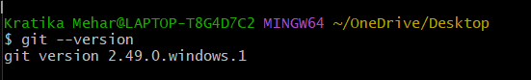

**Step 2: Configure Git Identity**

git config --global user.name "Kratika Mehar"  
git config --global user.email "meharpramod90@gmail.com"  
  
Verify:  
git config --global --list

Screenshot: Output of git config --global –list

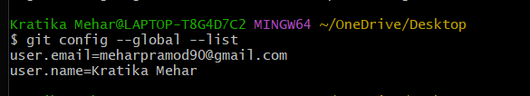

**Step 3: Set Notepad++ as Git Editor**

git config --global core.editor "notepad++ -multiInst -nosession"  
Verify:  
git config --global --get core.editor

Screenshot: Output of git config --global --get core.editor

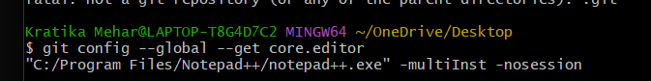

**Step 4: Create a Local Repository**

mkdir GitDemo  
cd GitDemo  
git init

Screenshot: Output after git init

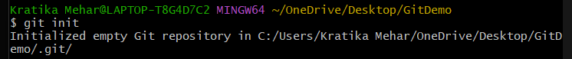

**Step 5: Create and Add File**

echo "Welcome to GitDemo" > welcome.txt  
git add welcome.txt  
git status

Screenshot: git status after adding welcome.txt

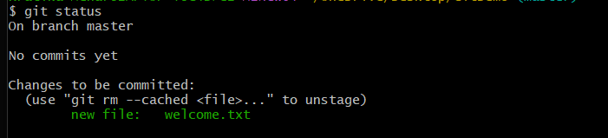

**Step 6: Commit Changes**

git commit -m "Add welcome.txt"

Screenshot: Output after git commit

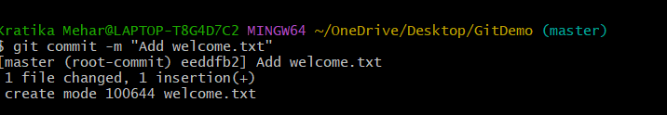

**Step 7: Create Remote Repository**

Go to GitHub/GitLab → New Repository → Name: GitDemo → Create.

Screenshot: New repository page on GitHub/GitLab

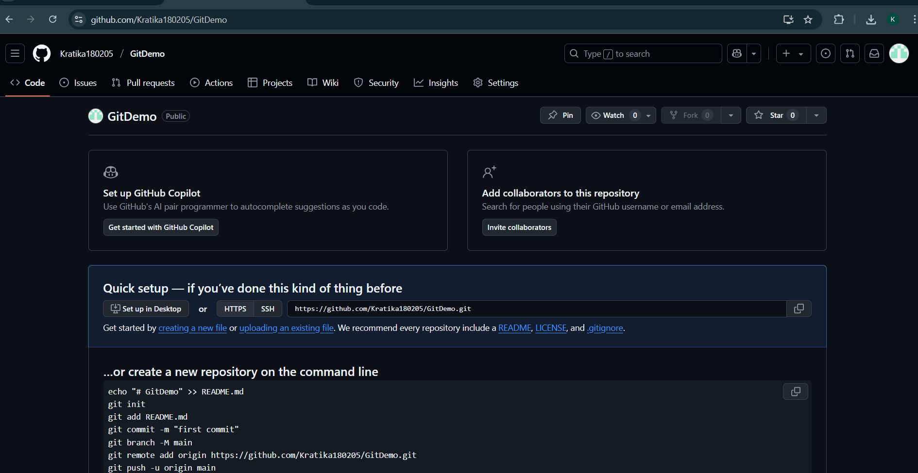

**Step 8: Push to Remote (main branch)**

git remote add origin https://github.com/Kratika180205/GitDemo.git  
git branch -M main  
git push -u origin main

Screenshot: Output of git push to main branch

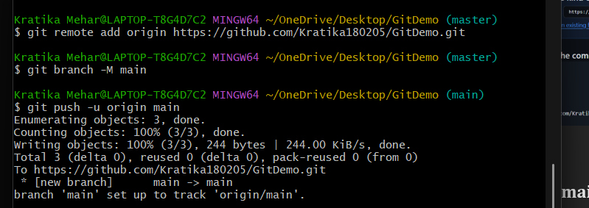

**Step 9: Pull from Remote**

git pull origin main

Screenshot: Output of git pull origin main

